**PRACTICAL-3**

**AIM: Write a C program to test whether a given identifier is valid or not.**

**CODE:**

#include<stdio.h>

#include<conio.h>

#include<string.h>

#include<ctype.h>

void main()

{

int i=0,flag=0;

char keyw[10][10]={"int","float","break","long","char","for","if","switch","else","while"},a[10];

clrscr();

printf("Enter identifier:");

gets(a);

for(i=0;i<10;i++)

{

if ((strcmp(keyw[i],a)==0))

{

flag=1;

}

}

if(flag==1)

{

printf("\n%s is a keyword",a);

}

else

{

flag=0;

if((a[0]=='_')||(isalpha(a[0])!=0)){

for(i=1;a[i]!='\0';i++)

{

if((isalnum(a[i]==0)) && (a[i]!='_'))

{

flag=1;

}

}

}

else

{

flag=1;

}

}

if(flag==0)

{

printf("\n%s is an identifier",a);

}

else

{

printf("\n%s is not an identifier",a);

}

getch();

}

**OUTPUT:**

**Test Case-1:**



**Test Case-2:**



**Test Case-3:**

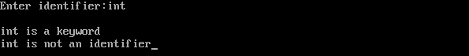

**Test Case-4:**



**Test Case-5:**



**Test Case-6:**

